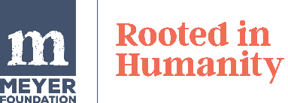

Meyer Foundation Rapid Response Application
Updated: January 22, 2025
Your Organization’s Information
- Organization’s legal name (and name it’s commonly known by)
- Address and telephone number
- Federal tax identification number (if you have one)
- Fiscal sponsor’s name and tax identification (if applicable)

Your Contact Information
- Application Contact: Name, title, telephone number, email
- Organization Chief Executive Contact: Name, title, telephone number, email

Your Proposal
Please share details about the proposed effort. Select all that apply:
☐Urgent community organizing
☐Unanticipated legislative, policy or ballot initiative campaigns
☐Strategic litigation or community defense funds
☐Communication campaigns
☐Organizationally distributed direct support
☐Mutual aid
☐Other (please specify)

If you selected other, please describe the request. We recommend responding in 50 words or less.

Amount of funding requested: Select either $10,000 or $20,000

Please answer the following questions. We recommend answering in a short paragraph of 100 words or less or a bulleted list for each question.

- Please describe the project you are hoping to support.
- Who else is involved with this project (e.g., additional organizations, coalitions, facilitators, etc.)?
- What will be better and/or different for your community as a result of this project?
- Do you feel you already have the organizational capacity, skills, and relationships to complete this project? Please describe some of the resources, processes, and tactics you possess that are needed to complete this work.
- How will you determine if this action is successful?
- How do you plan to spend down these funds in the 6-month timeframe?

