Moving From Vision to Implementation: Webinar Worksheet
Worksheet #1: Creating a Common Agenda
Instructions: Complete this reflection worksheet on your own and be prepared to share your reflections and outstanding questions with other webinar participants.
 | Status  Not yet developed; In progress; Completed | Success Factor(s) in  Getting Agreement | Looking Ahead:  Next Steps, Who to Engage, Potential Challenges
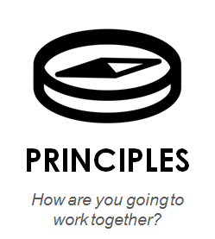
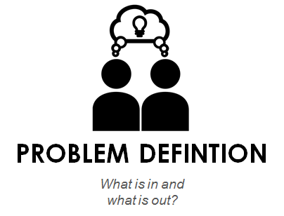
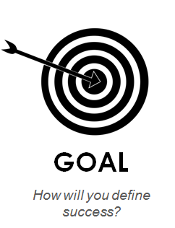
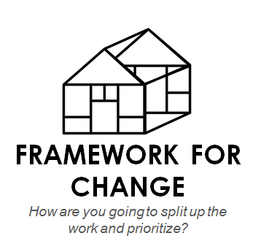
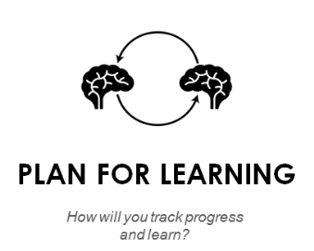
Worksheet #2: Strategy Development
- Think of a current or potential working group strategy for your initiative and write it below:
Description of strategy:
Who would be involved:
Expected output / outcome:

- How does / could this strategy create change in the system vs. be more programmatic? Share your thoughts / reflections below. The five types of systems-changing strategies are included below

Types of strategies in collective impact:
- Better understanding the current situation: aligning or overlaying existing data sets or systems with one another
- Learning by trial: identifying an opportunity to start small with willing partners, learn from the experience, and then expand or replicate
- Increasing coordination: finding ways to realign existing programs, protocols, and stakeholders to work together differently to maximize efficacy
- Enhancing services: adopting a previously unnoticed proven practice from inside or outside the community to enhance existing services or programs
- Identifying policy-change opportunities: looking for opportunities at local or state levels and relaying these to a Steering Committee and/or a policy and advocacy Working Group

- How did / could this strategy engage the community? First, identify the goal of your community engagement. Then use the spectrum of community engagement below to either document past community engagement activities or brainstorm potential new ones.
Community Engagement Goal:

Category | Inform | Consult | Involve | Collaborate | Co-lead
Definition | To provide the public with balanced and objective information to assist them in understanding the problem, alternatives, or solutions | To gather feedback from targeted stakeholders on the project’s goals, processes, shared metrics, or strategies for change | To work directly with stake-holders to ensure that concerns are consistently understood and considered | To partner with stake-holders in each aspect of decision-making, including the development of alternatives and priorities | To place final decision making in the hands of stakeholders so that they drive decisions and implementation of the work
Your ideas

